**Name: SREELEKSHMI ANILKUMAR**

**Roll No: 42**

**Batch:B**

**Date: 19-04-2022**

**ADVANCED DBMS LAB**

**Experiment No.: 5**

**Aim**

To familiarize with set operations

**QUESTION**

1. List all the customers who are depositors but not borrowers.

2. List all the customers who are both depositors and borrowers

3. List all the depositors having deposit in all the branches where Sunil is having Account 4. List all the customers living in city NAGPUR and having branch city BOMBAYor   DELHI

5. List all the depositors living in city NAGPUR

6. List all the depositors living in the city NAGPUR and having branch in city BOMBAY 7. List the branch cities of Anil and Sunil

8. List the customers having deposit greater than 1000 and loan less than 10000. 9. List the cities of depositors having branch VRCE.

10. List the depositors having amount less than 1000 and living in the same city as Anil 11. List all the cities where branches of Anil and Sunil are locate

12. List the amount for the depositors living in the city where Anil is living

**PROCEDURE AND OUTPUT SCREENSHOT**

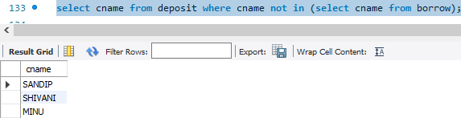

**2.**

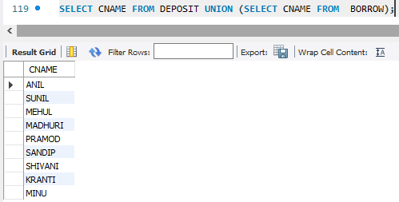

**3.**

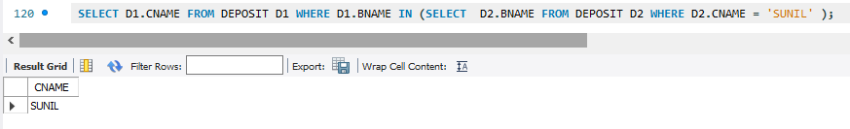

**4.**

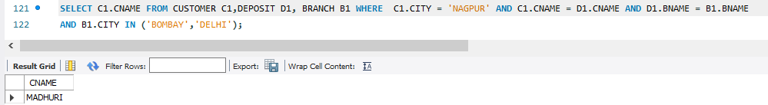

**5.**

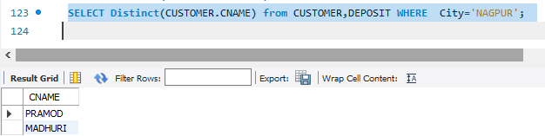

**6.**

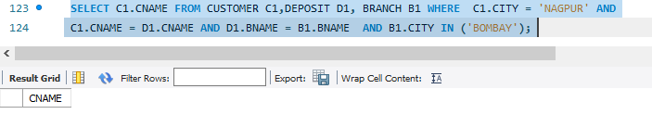

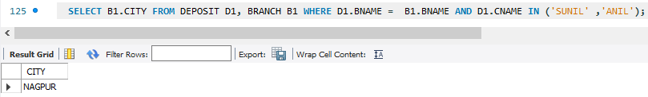 **7.**

**8.**

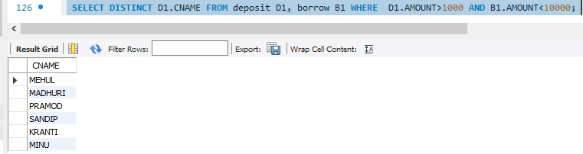

**9.**

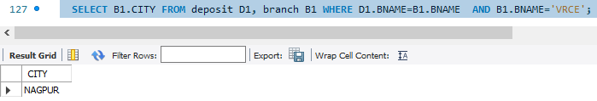

**10.**

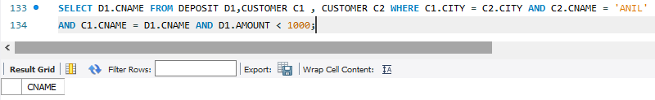

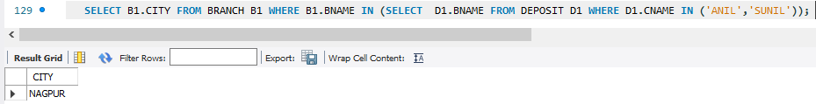**11.**

**12.**

